ATK-CLMP257B

Specification Document V1.1

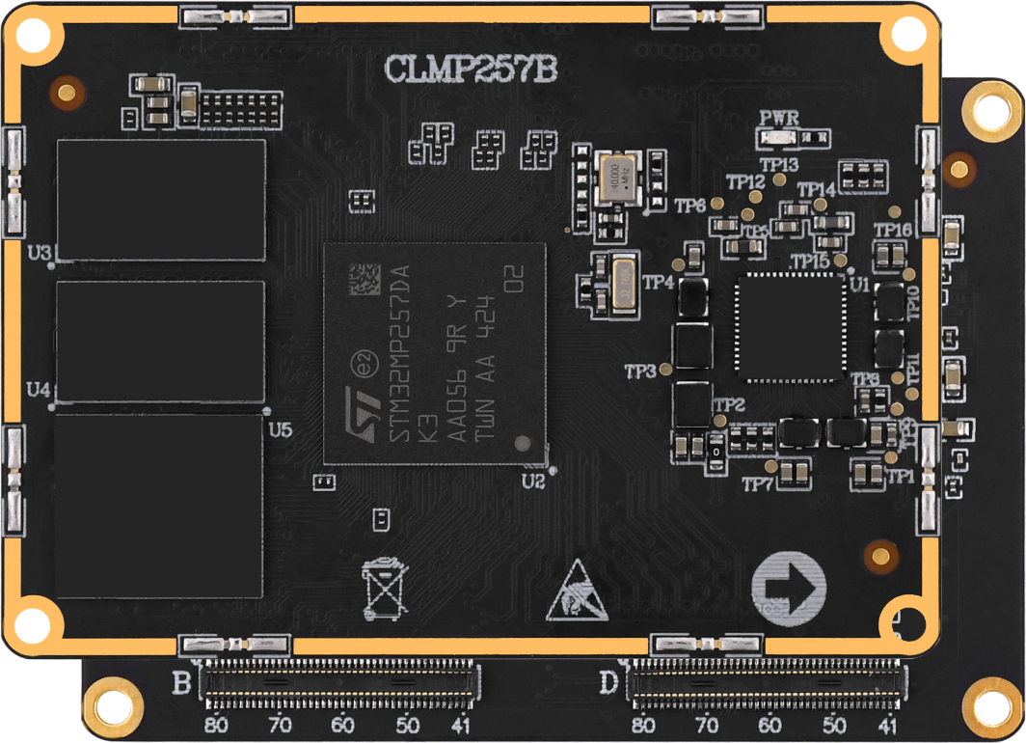



**1. Shopping：**

TMALL：<https://zhengdianyuanzi.tmall.com>

TAOBAO：<https://openedv.taobao.com>

**2. Download**

Address：http://www.openedv.com/docs/index.html

**3. FAE**

Website ：[www.alientek.com](http://www.alientek.com)

Forum ：<http://www.openedv.com/forum.php>

Videos ：[www.yuanzige.com](http://www.yuanzige.com)

Fax ：+86 - 20 - 36773971

Phone ：+86 - 20 - 38271790



**Disclaimer**

The product specifications and instructions mentioned in this document are for reference only and subject to update without prior notice; Unless otherwise agreed, this document is intended as a product guide only, and none of the representations made herein constitutes a warranty of any kind. The copyright of this document belongs to Guangzhou Xingyi Electronic Technology Co., LTD. Without the written permission of the company, any unit or individual shall not be used for profit-making purposes in any way of dissemination.

In order to get the latest version of product information, please regularly visit the download center or contact the customer service of Taobao ALIENTEK flagship store. Thank you for your tolerance and support.

**Revision History:**

|  |  |  |  |  |
| --- | --- | --- | --- | --- |
| Version | Version Update Notes | Responsible person | Proofreading | Date |
| V1.0 | release officially | ALIENTEK | ALIENTEK | 2025.04.01 |
| V1.1 | Add "Note" in section 3.4 | ALIENTEK | ALIENTEK | 2025.4.14 |

Catalogue

Introduction 1

Chapter 1. Product Overview 2

1.1 Application Areas 2

1.2 Data Download 3

Chapter 2. Product types choosing 4

2.1 Product Naming 4

2.2 Distinction between Commercial and Industrial Levels 4

Chapter 3. Product Parameters 5

3.1 Hardware Parameters 5

3.2 Core Board Resources 5

3.3 Pin sequence and interface signal 6

3.4 Reusable Function Resources for Pin Connections 7

Chapter 4. Software Resources 9

4.1 Factory System Firmware Resources 9

4.1.1 Basic Information 9

4.1.2 Driver and development routines 9

Chapter 5. Core Board Structural Dimensions 11

5.1 CLMP257B Structural dimensions 11

Chapter 6. Development Materials 12

6.1 Data Description 12

6.1.1 Documentation Tutorials 12

6.1.2 User Manual 12

6.1.3 Core board information 12

Chapter 7. Optional Accessories 14

Chapter 8. Product Usage Precautions 15

Chapter 9. After-sales Service 16

9.1 After-sales service Terms 16

9.2 After-sales Support 16

# Introduction

The ATK-CLMP257B core board is a high-performance embedded development platform developed by ALIENTEK based on STM32MP257DAK3 chip from ST. It is designed for embedded system development. This specification details the technical specifications, functional features and application scenarios of the core board, aiming to provide a comprehensive reference for developers and engineers to take full advantage of the core board in the product design and development process.

# Product Overview

The ATK-CLMP257B core board is a high-performance core board developed by ALIENTEK based on the STM32MP257DAK3 chip from STMicroelectronics, targeting the embedded Linux field. It is specially designed for embedded system development.

The STM32MP257DAK3 is equipped with two 1.5GHz Arm Cortex-A35 64-bit RISC cores, one 400MHz Arm Cortex-M33 32-bit RISC core, one 200MHz Cortex-M0+ 32-bit RISC core, and one 1.35 TOPS neural processing unit (NPU) and graphics processing unit (GPU), providing outstanding processing performance and edge AI capabilities.

This core board has three Ethernet ports with switch and TSN (Time-Sensitive Networking) support, and supports multiple functional interfaces such as FD-CAN, PCIe/USB 3.0, etc. It also supports parallel interfaces and MIPI CSI-2 for camera connections, as well as parallel interfaces, LVDS, and MIPI DSI for display output. It is highly suitable for embedded development evaluation, product application integration, etc.

In terms of memory, the ATK-CLMP257B core board is equipped with DDR4 RAM and provides eMMC storage space, meeting most of the development capacity requirements. In addition, this core board also has rich peripheral resources, including but not limited to I2C, SPI, CAN FD, UART, ADC, LCD, USB, and SDIO interfaces, providing users with more expansion and application possibilities.

ALIENTEK provides rich software and documentation resources for the ATK-CLMP257B series core boards and development boards, including U-boot, Linux kernel, peripheral driver source code, file system, Qt source code, C application source code, AI development source code, multi-core development source code, related development tools and development environments, etc. The documentation materials include tutorial documents and user manuals, covering Linux embedded driver development guidelines, Linux C application programming guidelines, multi-core communication routine user manual and AI development manual, etc., with a total of over 1500 pages. In addition, it also provides hardware materials, including development board PDF documents, development board AD packaging libraries, mechanical dimension diagrams, chip reference manuals, etc. These resources will help developers better utilize the functions and performance of the core board, accelerating system development and optimization cycles.

## Application Areas

图示

AI 生成的内容可能不正确。

Figure ‑ Some Application Domains

## Data Download

Download Center：[http://www.openedv.com/docs/boards/arm-linux/mp257hxb.html#/](http://www.openedv.com/docs/boards/arm-linux/mp257hxb.html%23/)

# Product types choosing

## Product Naming

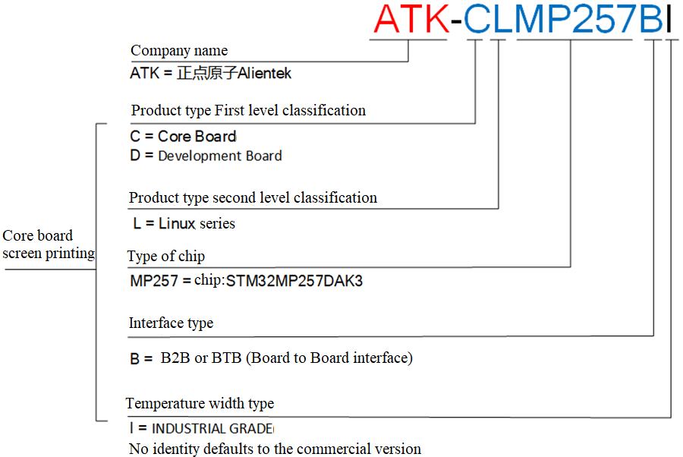

Figure ‑ Product Naming

## Distinction between Commercial and Industrial Levels

The ATK-CLMP257B series of core boards are classified into commercial-grade and industrial-grade versions based on the different operating temperatures for their application scenarios.

The operating temperature range for the commercial-grade core board is 0℃ to +70℃.

The operating temperature range for the industrial-grade core board is -40℃ to +85℃.

The silk-screened name of the commercial-grade BTB version core board is CLMP257B, while that of the industrial-grade BTB version core board is CLMP257BI.

Unless otherwise specified, the images in this document refer to the commercial-grade core boards.

# Product Parameters

## Hardware Parameters

|  |  |  |
| --- | --- | --- |
| **Project** | **Parameters** | **Remarks** |
| Core board size specification | 60mm*42mm |  |
| Processor model | STM32MP257DAK3 | VFBGA424 package |
| Processor architecture | Dual-core 1.5GHz Cortex-A35 + 400MHz Cortex-M33 + 200MHz Cortex-M0, integrated 1.35 TOP/s NPU, GPU |  |
| Power management | discrete power supply，STPMIC25D |  |
| Memory | 2GB DDR4（Standard equipment ）or  1GB DDR4 | The model is subject to the actual chip placement. |
| Storage | 16GB eMMC（Standard equipment）or  8GB eMMC | The model is subject to the actual chip placement. |
| Operating Voltage | 5V 1A | Power supply range: 5V ± 200mV |
| Power Consumption | < 1W | Minimum system power consumption of the core board |
| Operating Temperature | Commercial grade：0℃ ~ +70℃ |  |
| Industrial grade：-40℃ ~ +85℃ |  |
| Number of interface pins | 320PIN |  |
| Pin pitch | 0.4mm |  |
| Interface form | Four 2*40 anti-reverse-insertion BTB male sockets, board-to-board connection |  |
| PCB process | 10 layers, separate layer, power layer |  |

## Core Board Resources

The ATK-CLMP257B core board mainly integrates the STM32MP257DAK3 processor (including dual-core Cortex-A35, Cortex-M33 and Cortex-M0+), and is equipped with DDR4 memory and eMMC storage to provide efficient data processing and storage capabilities for the system. The core board is equipped with a high-efficiency PMIC power management chip STPMIC25D, which is designed to meet the power requirements of multi-core systems.

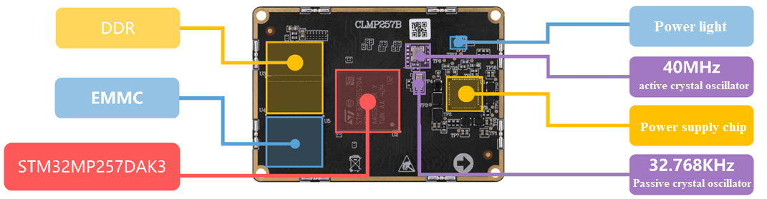

Figure ‑ Frontal Resources of CLMP257B Core Board

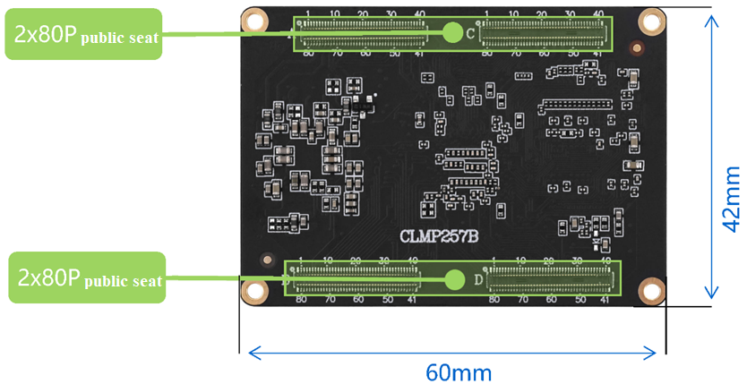

Figure ‑ Backside Resources of CLMP257B Core Board

## Pin sequence and interface signal

The PINOUT part of the ATK-CLMP257B core board is the pin definition corresponding to the BTB connector of the core board. This connector is a specification of 4 pairs of 2* 40pins, with a total of 320 pins.

The back of the core board has the pin number silk screen printed as follows:

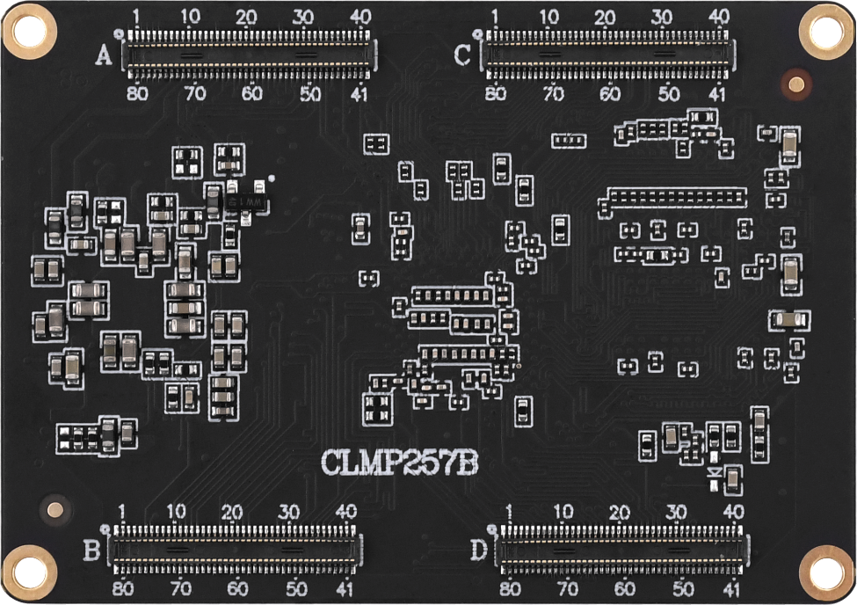

Figure ‑Backside of the core board

It can be seen that on the backside of the core board there are a pair of BTB connector male sockets. The one on top is D and B, and the one at the bottom is C and A. They are respectively labeled with pin numbers 1, 40, 41, and 80, and correspond one-to-one with the pin numbers of the BTB female socket on the baseboard.

For specific pin function definitions, see the ATK-DLMP257B base plate schematic diagram.

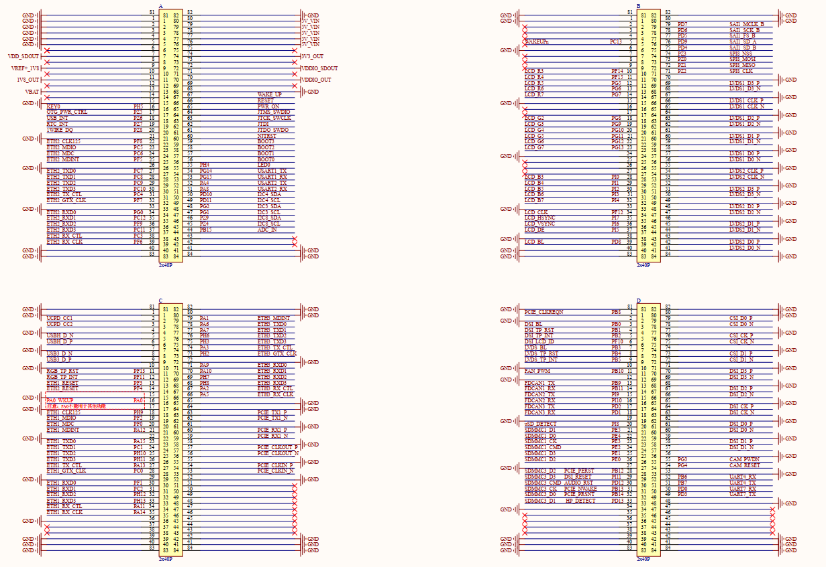

Figure ‑ The schematic diagram of the base plate and the definition of its pins

Here only the functions used by the core board on the base board (that is, the default factory system functions) are described. If you want to check the re-usable pin functions, please refer to the document "【ALIENTEK】ATK-CLMP257B Core Board Interface Data Sheet V1.0.xlsx".

## Reusable Function Resources for Pin Connections

The core board has brought out most of the I/O resources on the processor. Users can design the baseboard according to their own needs to utilize the I/O resources on the core board and reassign them to the functions they require.

According to the peripheral functions, here are the maximum resource numbers of individual peripherals that the ATK-CLMP257B core board can reuse. The specific selection can be combined with the data sheet of the chip (maximum resource number of individual peripherals: refers to the maximum number of a certain peripheral that the core board can use without using other peripherals).

|  |  |  |  |
| --- | --- | --- | --- |
| **Peripheral Function** | **Maximum Reuse Number of a Single Peripheral Function** | **Peripheral Function Maximum Reuse** | **Number of a Single Peripheral Function** |
| GPIO | 144 | Ethernet | 3（GMAC+GMAC/ETHSW） |
| I2C | 8 | MIPI DSI | 1，4 lanes |
| I3C | 4 | MIPI CSI | 1，2 lanes |
| UART/USART | 9 | Parallel CSI | 1 |
| SPI | 8 | RGB LCD | 1，24b，1080p@60fps |
| Octo-SPI | 2 | LVDS | 2，4 lanes |
| I2S | 3 | ISP | 1 |
| SAI | 4 | ADC | Three, 21 channels, 12 bits |
| SPDIF | 4 | Timer/PWM | 34 |
| SDMMC | 3，SD / eMMC / SDIO | WDOG | 7 |
| USB 2.0 HOST | 1 | JTAG | 1 |
| USB 2.0/3.0 | 1 | LPUART | 1 |
| CAN&CAN- FD | 3 | FMC | 1 |

Note: Two Gigabit Ethernet GMAC interfaces are provided: one with an optional PHY interface; The other is connected to an external PHY interface and optionally via an internal embedded Ethernet switch, which supports two external PHY interfaces.

# Software Resources

## Factory System Firmware Resources

### Basic Information

|  |  |  |
| --- | --- | --- |
| **Type** | **Description** | **Remarks** |
| U-Boot | Version: 2023.10 | Provide the source code |
| Linux kernel | Version：6.6.48 | Provide the source code |
| Root file system rootfs | Yocto root file system | Provide a mirror image |
| Buildroot root filesystem | Provide a mirror image |
| Debian root filesystem | Provide a mirror image |
| Qt | Version：5.15 | Provide the source code |
| Inter-nucleus communication | Version：1.0.0 | Provide the source code |
| AI development | Version：1.0.0 | Provide the source code |
| Cross-compiler | openstlinux-weston,  version 5.0.3-snapshot | Provide software |
| System flashing | STM32CubeProgrammer | Provide tutorials |

For more information, please refer to the "ATK-DLMP257B Quick Experience Manual".

### Driver and development routines

○ : Provides source code

◎ : Provides source code and tutorial materials

|  |  |  |  |  |  |
| --- | --- | --- | --- | --- | --- |
| **Peripheral function** | **Drive development** | **Application development** | **Qt development** | **Different core development** | **AI development** |
| GPIO | ◎ | ◎ | ○ | ○ |  |
| LED | ◎ | ◎ | ◎ | ◎ |  |
| KEY | ○ | ◎ | ○ | ◎ |  |
| RGB LCD | ○ | ◎ | ○ |  |  |
| LVDS | ○ |  | ○ |  |  |
| UART&USART | ○ | ◎ | ○ |  |  |
| I2C(AT24C64) | ○ |  |  | ◎ |  |
| SPI(W25Q128) | ○ |  |  | ◎ |  |
| USB | ○ |  |  |  |  |
| ETH(YT8531C) | ○ | ◎ | ○ |  |  |
| PWM(FAN) | ○ | ◎ |  | ◎ |  |
| MIPI DSI | ○ |  | ○ |  |  |
| MIPI CSI(IMX335) | ○ |  | ○ |  |  |
| WIFI&BT(RTL8733) | ○ |  |  |  |  |
| RS232 | ○ | ◎ |  |  |  |
| RS485 | ○ | ◎ |  |  |  |
| CAN&CANFD | ○ | ◎ |  | ◎ |  |
| ADC | ○ | ◎ | ○ | ◎ |  |
| AUDIO(ES8388) | ○ | ◎ | ○ |  |  |
| PCIE 2.0 / USB 3.0 | ○ |  |  |  |  |
| RTC(AT8563T) | ○ |  |  |  |  |
| TF Card | ○ |  |  |  |  |
| 4G(EC20&ME3630 ) | ○ |  |  |  |  |
| JTAG | ○ |  |  |  |  |

# Core Board Structural Dimensions

## CLMP257B Structural dimensions

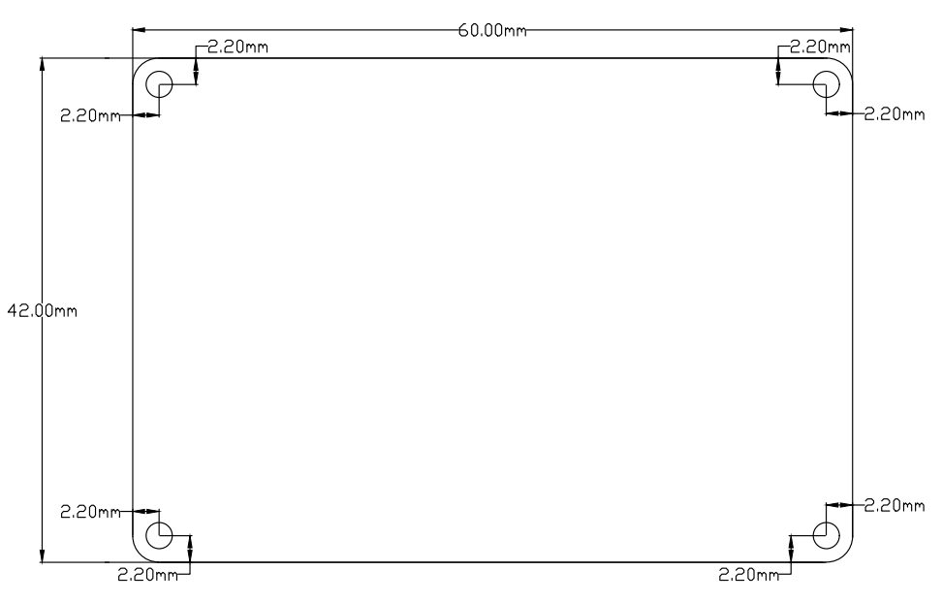

Figure ‑ ATK-CLMP257B core board mechanical structure

# Development Materials

## Data Description

### Documentation Tutorials

|  |  |
| --- | --- |
| **Material** | **Description** |
| ATK-DLMP257B Embedded Linux Driver Development Guide | Kernel subsystem learning, development board configuration description |
| ATK-DLMP257B Embedded Linux C Applications Programming Guide V1.0 | Application programming learning based on factory system |
| ATK-DLMP257B Embedded Qt Development Foundation | Embedded Qt development case study |
| ATK-DLMP257B Rapid Development Manual For Heteronuclear Communication V1.0 | Heteronuclear communication learning between A35 and M33 |
| ATK-DLMP257B Embedded AI Development Manual | Embedded AI Model Development and Optimized Deployment Learning |

### User Manual

|  |  |
| --- | --- |
| **Material** | **Description** |
| ATK-DLMP257B Quick Test Manual V1.0 | Development of board burning system, preparation for use, functional test |
| ATK-DLMP257B Hardware Reference Manual V1.0 | Development board hardware resources description, use precautions |
| ATK-DLMP257B Development Board Specification V1.0 | Development board specification, pre-project selection reference |
| ATK-DLMP257B Virtual Machine Usage Reference Manual V1.0 | Built virtual machine, installation and basic instructions to use |
| ATK-DLMP257B Factory System NFS Setup Manual V1.0 | Development board factory system NFS configuration and testing |
| ATK-DLMP257B Factory System TFTP Setup Manual V1.0 | Development board factory system TFTP configuration and testing |
| ATK-DLMP257B Porting Debian Reference Manual V1.0 | The development board builds the Debian minimal root filesystem |

### Core board information

|  |  |
| --- | --- |
| **Material** | **Description** |
| ATK-CLMP257B Core Board Specification Document | Core board specification for pre-project selection |
| ATK-CLMP257B Core Board Interface Data Sheet | Core board interface pin function description |
| ATK-CLMP257B Core Board Use Precautions | Core board use precautions, small system board design instructions |
| ATK-DLMP257B Factory System Peripheral Reuse Manual | Core board interface peripheral function modification |
| ATK-CLMP257B Mechanical Dimension Drawing Of Core Board | Core board mechanical dimension data |
| Schematic diagram of ATK-DLMP257B Base Board | Schematic diagram of the development board |
| ATK-DLMP257B Base Board package library | Development board integrated encapsulation library |

# Optional Accessories

The ATK-DLMP257B development board can be used with the ATK-MCIMX335 module of the positive dot atom to provide good performance and effect. At present, the development board has been adapted to some modules. If you need more adaptation modules of ATK-DLMP257B development board, you can contact the technical support of ALIENTEK official flagship store for consultation.

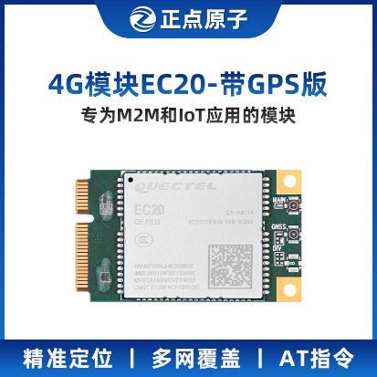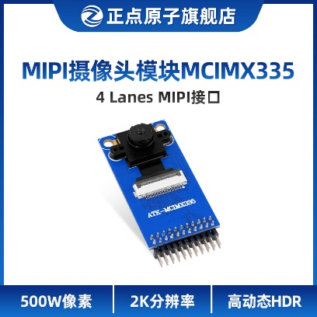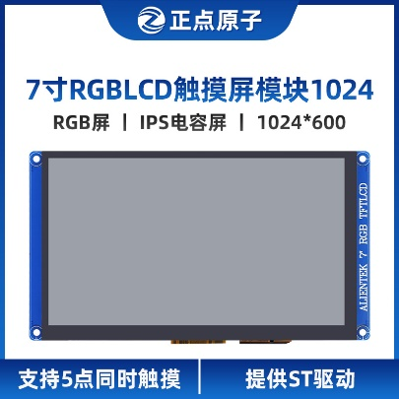

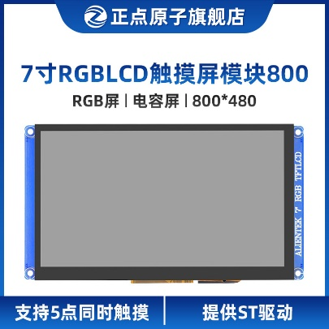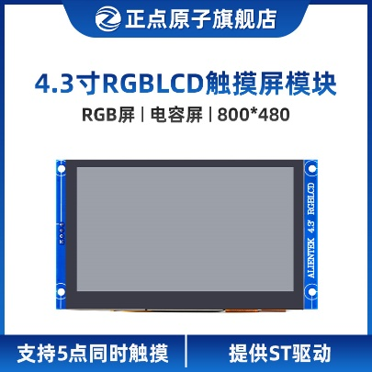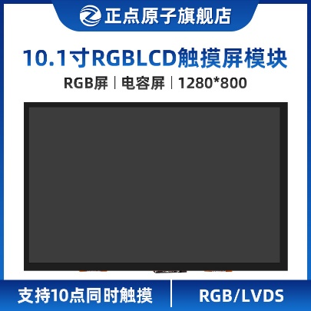

# Product Usage Precautions

* Do not plug or unplug peripheral modules while powered on!
* Before using the product, please carefully read this manual and related development manuals, and pay attention to the applicable matters of the platform.
* Please follow all the guidelines and warning information marked on the product.
* Use this product in a cool, dry, and clean place.
* Keep this product dry. If any liquid is splashed or soaked onto it by accident, please immediately cut off the power supply and fully dry it.
* Do not use organic solvents or corrosive liquids to clean this product.
* Do not use this product in dusty or messy environments.
* If not used for a long time, please package this product well and pay attention to moisture-proof and dust-proof.
* Pay attention to the ventilation and heat dissipation of this product during use. Avoid overheating during operation to prevent damage to components.
* Do not use this product in alternating cold and hot environments to avoid condensation damage to components.
* Do not handle this product roughly. Dropping, knocking, or vigorous shaking may damage the circuit and components.
* Pay attention to preventing static electricity during use of this product.
* The FPC soft flexible cable is relatively fragile. When plugging or unplugging the cable, pay attention to checking whether the metal tabs at both ends of the cable are misaligned or fallen off.
* All products are tested before shipment. For the first use, please power on test with the development board corresponding to Point Atom.
* Do not repair or disassemble our products without authorization. If the product malfunctions, please contact us for repair in time.
* Unauthorized modification or use of unauthorized accessories may damage this product. Damages caused thereby will not be repaired.

# After-sales Service

## After-sales service Terms

1). After receiving the goods, please open them in front of the express, and sign after acceptance. If you find that the goods are less after signing, take photos in time and contact the seller's customer service to explain the situation within 15 days. If the feedback is lack of goods after 15 days, we will not reissue the goods. Other reasons notwithstanding).

2). 15 days -1 month: we are responsible for the return freight repair of product problems. Human factors damage expensive main chip or LCD screen, touch screen. The buyer needs to pay the cost and one time shipping fee, no maintenance fee.

3). 1-3 months: the problem of the product itself (non-human factors), we are responsible for the delivery of the past freight maintenance. If the main chip is burned out and the LCD screen and touch screen are damaged, the buyer needs to pay the cost, and the maintenance fee is not charged.

4) After 3 months: the buyer shall bear the return freight and the cost of chip, LCD screen and touch screen. No service charge.

## After-sales Support

Technical support docking mode

QQ group: Taobao contact customer service

Taobao shop: Zhengdian atomic flagship store

Forum: <http://www.openedv.com/forum.php>